**Lab Management System - Vision**

**Introduction**

A lot of devices are used in the labs of the construction department. These devices can be used by different lab users, both students and researchers. For most experiments, standards are being followed. Therefore it is necessary to use both the devices and the labs efficiently. To make this happen in the most efficient way, a good planning is needed!

Currently, an online calendar system is being used to book equipment. This system helps to get a nice overview of all activities in the lab, but it does have several limitations that need to be taken into account:

* Double booking
* Continuity of experiments
* Opening hours
* Closing days + weekends
* Overview of all activities in the lab in one calendar (at the moment this is only possible by using multiple calendars = not so user friendly)

The construction department is therefore looking for a Lab Management System (LMS) which makes it possible to overcome the limitations of the online calendar system. In addition, some extra functions need to be added to the LMS, such as:

* Stock management
* User management
* Database + Reports
* Device information (including maintenance and calibration)

**Planning tool**

This is the most important part of the whole LMS and will be quoted as such at the end of the process. Because of the complexity of the planning tool, a step-by-step plan of action for experiments has been set up, with various levels of difficulty, going from easy to expert. Two examples are prepared in order to give an idea on how all different steps should work.

First of all it is important to understand the difference between a step and an experiment. A step is when someone books one device at one specific moment in the calendar. An experiment is a combination of steps. The lab user should be able to choose two options, namely a fixed experiment and a custom experiment. The lab managers are able to select an extra option, namely a new experiment. More on all of this is explained later in this document.

**Fixed – Custom – New**

Two fixed experiments are given and need to be implemented in the planning tool. The wheel tracking experiment is a relatively easy experiment with not to many devices and not so strict boundary conditions. The ITS-R experiment on the other hand, is a more complex experiment. More information on these experiments can be found later in this document.

A lab user needs to be able to make a custom experiment. This is basically a step by step booking of different devices. For custom experiments, the same boundary conditions apply as for the fixed experiments (except for the continuity).

The lab managers should be able to make new experiments. This can be seen as some sort of design tool to “build” an experiment the same way the fixed experiments were built. All experiments (new and fixed) should also be adjustable. It sometimes happens that there are slight changes in standards. Whenever this happens, the lab manager needs to be able to adjust certain experiments.

**Easy**

In the easy version of the LMS, a lab user should be able to book a device at any moment he/she wants. The only boundary condition is that double bookings should be avoided. When someone tries to book a device which is already booked on the specific moment, the lab user who’s trying to make a booking should get a notification that it is not possible to book that device on that moment. The moment a booking is made, it needs to be visible in the calendar. When opening the calendar, an overview is shown of all bookings.

**Medium**

Working according to standards often implies working with a certain continuity of tests. There are two kinds of continuities, soft and hard. A hard continuity means that step B follows at X amount of time after A. This time X is fixed, it cannot be longer or shorter. With a soft continuity, this time X is not fixed. Is can be either **at least** or **at most** time X. So far, the planning tool does not need to take opening hours into account!

**Difficult**

In this phase, two extra’s are being implemented. First of all opening hours are taken into account. The lab opens at 9:00 and closes at 17:00. Therefore, the start and the end of a booking should always be within this timeframe. Most of the devices are only used during the opening hours of the lab, so they cannot be booked outside of opening hours. However, for some devices it is allowed to book them outside of the opening hours (as long as the start and the end of the booking are within the opening hours). A list of all devices and their availability can be found further in this document.

A second part that needs to be implemented in the difficult phase is stock management. Whenever bookings are made, raw materials (aggregates) are used. The moment raw materials are going to be used, they need to be taken out of stock. The lab user will need to give the exact amount (or at least an estimate) of raw material that he/she will be using. This amount needs to be extracted from the overall stock of that material. More information on stock management can be found further in this document.

**Expert**

For the expert level, a couple of extra features need to be implemented. First of all closing days and weekends should be taken into account for all bookings. When a lab user tries to book an experiment for which work during the weekend (or a closing day) is needed, the planning tool should give a notification and show different options for an alternative (optimal) planning without work during the weekend.

Secondly for every new booking, the planning tool automatically checks the capacity of all devices. When booking an experiment (or individual steps) the planning tool automatically gives at least one suggestion on a planning that is as close to the requested as possible (start- or enddate).

**Stock management**

The lab of the construction department has a wide variety of raw materials at its disposal. All these raw materials are being consumed during production of different samples. The stock management system must work in such a way that when samples are produced, the lab user can specify in the booking which raw materials (and how much of it) is being used. This is done with predefined mixture compositions. Three basic mixtures are given, but for the future it should also be possible to add new mixture compositions. Certain lab users should also have the possibility to add a new mixture composition in the system. These users will be defined at a later stage. Finally, users should only have access to certain mixtures.

In the stock management system, it is important that the user at all times can request an overview of the quantity of the raw materials that are still present. It should also be possible to request a history of consumption of all raw materials. The lab managers should be able to manually adjust the amount of raw materials in stock at any time.

Depending on the type of raw material, different unit can be used. An amount of aggregates is shown in kilograms and an amount of bitumen is shown in liters. For other purposes (in the future?) an amount in pieces is also useful.

A graph shows the usage over a period of 6 months in details (visible on the graph). It should be possible to go back to the beginning of time (with always 6 months visible on the graph).

**User management**

For different users, different access rights apply. Five different access right are used:

* Read only – Basic – Limited details visible (administrator determines limitations)
* Read only – Advanced – All details visible
* Modify – Basic – Not specified (might be used in the future)
* Modify – Advanced – Read all + Add own/promotor
* Modify - All

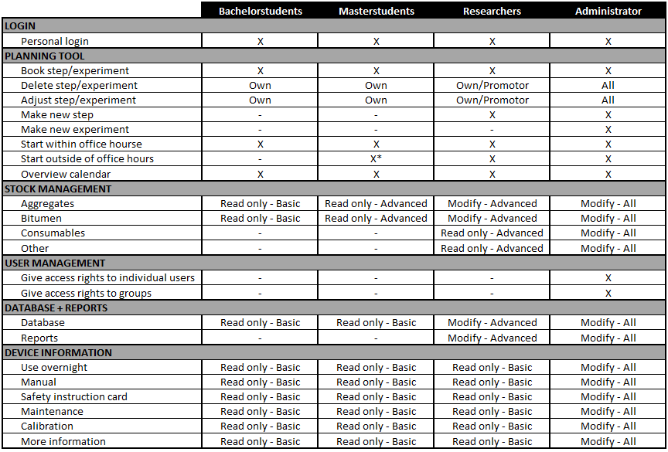

*Promotor is responsible for lab permanence !!!

**Database + Reports**

Under construction – More information to be given by mid March!

**Device information**

**Devices**

The lab of the construction deparment has a numerous variety of devices. For the first part of the LMS, only a limited amount is used. Therefore, adding new devices (in the future) should be possible. The limited devices that are used are:

* Autosaw
* Balance
* Big mixer
* Caliper
* Cooling chamber
* Gyratory
* Ovens
* Plate compactor
* Small mixer
* SVM setup
* Uniframe
* Vacuum setup
* Water bath
* Wheel tracking test

**Information**

All kinds of information is available for each device. The most important information concerning the planning tool is the possibility to use a device overnight. Besides this, for all devices the following information should be available:

* Manual
* Safety instruction card
* Maintenance
* Calibration
* More information (can ben anything)

**Statistics**

How many hours was a device booked? For most devices, it possible to be booked 8 hours per day (for devices that cannot be booked overnight), for a total of (let’s assume) 200 working days. This gives a total of 1600 hours of potential booking for each device. If the device was booked for 960 hours, it had an occupancy rate of 60%. This doesn’t mean the device was actually used for 960, but this is not traceable, so we only take booking statistics into account!

How many days was a device booked? It’s perfectly possible that a device with an occupancy rate of 60% (see above) was booked on 180 different days. This rather implies a occupancy rate of 90%.

These statistics can give us a better insight into how much flexibility there is for each device. This information is necessary in view of maintenance, calibration, purchase of new devices, … .